Seniors Managing Diabetes

|  |  |  |  |  |
| --- | --- | --- | --- | --- |
| Jeremy Johnston  University of Toronto  Toronto, Canada  jeremy.johnston@mail.utoronto.ca | Jhony Campanha  University of Toronto  Toronto, Canada  j.campanha@mail.utoronto.ca | Joseph Lee  University of Toronto  Toronto, Canada  josephl@live.ca | Eric Siu  University of Toronto  Toronto, Canada  eric.xue@mail.utoronto.ca | Marc de Niverville  University of Toronto  Toronto, Canada  marc.deniverville@mail.utoronto.ca |

# ABSTRACT

Within the increasing popularity of smartphones and the importance for health care systems, our research intend to build an application to help in the diabetes self-management. Since seniors are most commonly diagnosed with type 2 diabetes, we would like to have them as our target users, and provide them an easy and useful application.

## Keywords

Diabetes; seniors; self-management; health tracking app.

# introduction

Currently, the use of technology is increasing and becoming more popular. People from all age range are getting used to smartphones, tablets or even desktops. Because of that, we would like to develop some application which could help users to manage their health conditions within these technological devices. Since there are a lot of different applications for self health management, we would like to give attention to a specific user group who are lacking in attention and usually having difficulties with the available applications: seniors.

In order to have a useful and simple application, we decide to focus our research in diabetes self management because it is one of the biggest health problems which seniors are usually suffering from. Our main objective is to understand seniors’ current difficulties with the available applications and their own issues while monitoring/managing their diabetes in order to get a simple and useful application.

# User group

We intended to focus our research in seniors suffering from diabetes (type 1 or 2) who need help for the self management of their health condition. Currently, the users are used to follow a monitoring routine, measuring their blood glucose levels. This routine is important to keep symptoms under control; however, many users report that this routine is stressful, and that is why we chose to develop some application to help them. Moreover, we expect to understand seniors’ difficulties with technological devices because we need to build an understandable, easy to use and useful application for them.

# high level research plan

After deciding the problem space and the user group, each of us chose an aspect of problem space and started looking up relevant academic publications. From our summary result, we found out that the simplicity of a digital app is proportional to the user satisfaction. Moreover, the opportunity to make them closer to the health professionals by using technology is a great desired aspect. By using this feature, taking care of the issues behind diabetes become possible. During our research, we must find out what digital technologies have been most widely adopted because it is important to identify what technologies users have adopted, as adopting a new technology is actually a behaviour change and people can only make one behaviour change at a time.

In order to get information about their current health management routine and their difficulties with possible used technology, we started looking for seniors with diabetes who could help us to find these information. We found some participants in some local diabetes support groups, researchers’ relatives and/or the Banting & Best Diabetes Centre (BBDC) at the University of Toronto.

The purpose of the research with these participants is to understand their current diabetes self management routine, such as important measures and medications that they need to take and the exact time of each activity. Furthermore, we expect to understand their difficulties with their regular schedule, such as forgetting to measure or to take medications. In addition, since we are working with technological devices, we will try to understand their difficulties in using this kind of devices.

The user research was conducted in 3 ways: questionnaire, interview and observation study. For the interview, we asked our participants their opinions on some current health management tools/aids. It includes what they like about those tools and what trouble participants have with them, as well as the difficulty of learning them. The interview was semi-structured and we would refer to the interview script during the talk. The questionnaire covers similar topic as the interview. It has some open-ended questions, leaving freedom of ideas to the participants. Finally we observed participants by giving them a mobile application / device (preferably health-related) and ask them how much they can figure out of the application in the allotted time. Their attitude towards the device and their emotion were also going to be observed when they are using the apps. All participants must sign the consent form and read the research protocol before proceeding to user research.

# User research results

In this section, the group consolidated its user research to generalize the results and finalize the direction of the project. A spectrum of users were recruited for interviews and completion of questionnaires, from people who had fairly recently been diagnosed with diabetes to some that had been managing the disease for most of their lives. All were seniors. They also demonstrated a spectrum of needs and abilities with manipulating technology; age was not correlated with technical aptitude or interest.

## Research Results Summary

The research that was conducted individually in our group was mainly focused on seniors with diabetes, and their interaction with technology. Through this research, we were able to find a few similarities among the seniors that suffer from this condition. For example, many of the seniors did not find hard to manage their condition. Although they did not have trouble managing it, it took them years to get used to their schedule and remembering every procedure. For those that were cared by medical professionals, they were guided in a professional manner and were able to adapt to the condition faster than some of the other seniors who did not receive this professional attention. Not only were they able to get familiar with their condition, but those who had visited a medical professional often also had more modern technology and received instruction in how to use them.

Moreover, many of the seniors also found that technology itself is not useless, but rather the application interface may not be suitable. They believed technology was the right way to go but the applications designed for it were poorly made. This includes the fonts, pictures, size of texts, and visual issues.

We also learned what means to manage diabetes on a daily basis. It involves balancing three factors: food intake, exercise, and insulin boost. The only concrete information that is available to them is their blood-glucose (BG) levels at a point in time: when they obtain a reading from their BG measuring devices. They rely on periodic check-ups with their physician, who performs more extensive blood work, to learn of the long-term trends for BG and get advice on how to adjust their daily regimen.

Lastly, it was found that some of the seniors did not approach the technology because they were unsure of how efficient and how accurate it is. They would have no problem in learning it, but sometimes the technology is complicated and no one is there to help them, so they would rather stick with old technology.

**Users’ needs**

Based on our research, the identified user needs an application which cares for helping, since the learning curve, and then maintain an established daily regimen, with advice on meal choices and reminders.

Briefly, people who have been newly diagnosed with diabetes need help with learning how to manage their condition; those who have become familiar with the methods must maintain the routine. We have identified specific needs: enhanced information and reminders.

## Key Persona

Given that the group identified at Users’ needs subsection are most acute when they are learning how to manage the disease, we chose to model our key persona on a new user: Jill, newly diagnosed with type 2 diabetes, comfortable with browsing the web with a PC, but relying on others to resolve any technical issues.

## DESIGN REQUIREMENTS

The problem that we are addressing is how elders with diabetes manage their health. With old age comes memory loss and the possibility of living on your own. Thus our job is to help elders keep track of what matters when it comes to managing their health. This means that monitoring blood sugar, getting exercise, reminders for insulin intake and dietary choices are our top priorities.

## Design Principles

In order to get the best final interface, we expect to follow this principles which follows users’ needs. As decided, the design needs to be:

* Simple - Our audience needs to be able to use the app without help and thus it should be very intuitive.
* Streamlined - There will not be clutter or an overuse of visual elements and features. Our users will be using our app for a specific purpose and we do not need to overwhelm them with options they will never use.
* Intelligent – Exercise and dietary advice needs to good advice. Also need to not annoy the users with the reminders.

## Environmental Requirements

Our app is meant for personal use and can be used in any environment. Logs will be updated after an exercise section of after a meal.

## Functional Requirements

Our app will need to be able to keep track of one month of information such as blood sugar level, exercise logs and food logs. It will also need to be able to set reminders for when to eat, take insulin or some medication or exercise. The logs should be able to be viewed and be kept track of for up to a year. The reminders should be set by the user and automatically by the system. Reminders can be set anytime daily, monthly, weekly or monthly intervals.

## Technical Requirements

Our app needs to be able to work on a portable and lightweight device in which users can keep the device with them at all times. The device should also be able to emit noise and vibrate in order to notify the user of the reminders. We will also need enough money to keep logs of exercise, meals and blood pressure.

## Usability Requirements

Our app should be incredibly easy to learn and user since our user group are seniors and they need to be able to use it without help. Any errors should not affect the logs already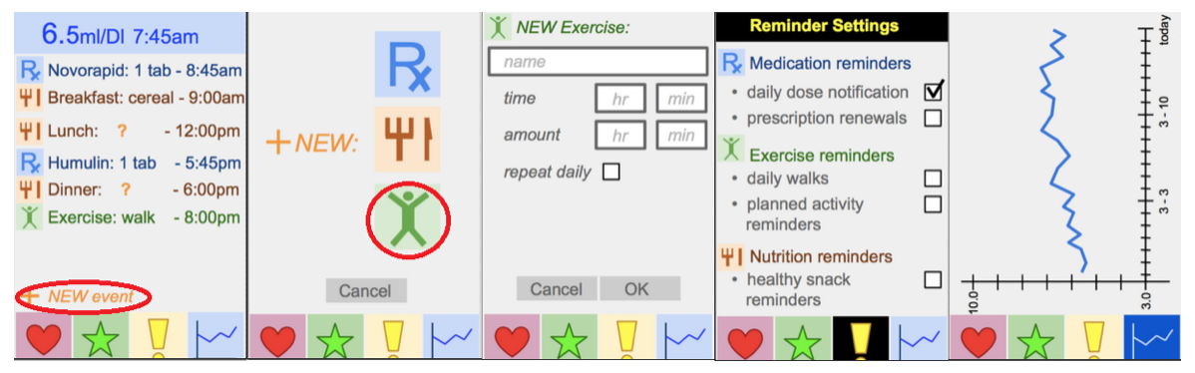 recorded neither the reminders that have been set as they are the most important features of the system.

Figure 1. Final first prototype

## DESIGN PROTOTYPES

The results of our research and completion led to our prototype for our application. Our research includes preparing our own prototype for the application for the seniors to use and the feedback received given from fellow peers and researchers. All of the group members devised their own interpretation of what the application would look like, and from it we decided that there were certain aspects from each of them that we liked, and some that we did not like. The prototype can be tested at https://popapp.in/w/projects/5506362a2889538b22927dd8/preview/550787aa8068e27f6d59b3e1

## Negative Features

Some of the ideas that we did not like where thought to be more of a luxury rather than a necessity, as we wanted to get the main problem attended to. An example of what we deemed as unnecessary for the application was the ability for the buttons to enlarge and show explanation of its function. Another one was for the application to have more than one user, in case for multiple people interacting with the device. In addition, we also decided against a feature that has the user interact with a drag-and-drop event to aFigure 2. Sample of a wide figure. Be sure to place at the top or bottom of the page. Ensure that important information is legible in both black-and-white and color printing. Image: CC-BY-ND ayman on Flickr.
 graph.

Figure 2. Drag-and-drop function to add new event.

Of course the features listed above were not the only disagreeing ones, there were several more that came up in our discussion. Currently, we decided to not include multiple languages for simplicity sake, and we also voted against an idea of including a bar graph that stacks which corresponds to the user’s entries. Similarly, we decided to get rid of a prediction chart with events, as it can be misleading if predicting the wrong output.

## Positive Features

Based on all of our collective research, we came to a conclusion of what the application should look like. There were many ideas that we thought were good and we made the best of all worlds by making a collaborated product.

As can be seen on Figure 1, each screen has the “menu” bar at the bottom present, which allows for easy navigation through certain categories. Our home menu (first screen) has a layout of the day and a summary of the itinerary, as well as the last dosage of medicine at the header. Creating a new log is as easy as pressing the “+” and selecting an icon. Inputting the details will add it to the home screen, and it could be done with medicine, diet, or exercises. Reminders have their own category as it is important for people who have hard remembering events, and as an application we want it to be as helpful as possible. Lastly, an important implementation is the tracking of the blood sugar levels in the patient, and as the user enters the info, it will appear on the line graph tracking their levels and what time of the day it was recorded.

This final design show on Figure 1 was created mixing good ideas from each prototype. For example, the idea of the home menu having a summary of the condition of the user based on the inputs, the simplified logos and used the blood sugar level graph to help navigate visually easier, the interface for input of the logs are from and the “+” sign was added to have the iconic “add more” events, and the reminders system was incorporated through simple notifications were all based on different prototypes. After combining these, we refined the details and looks of it and made it more aesthetically pleasing, as well as simple and effective.

Figure 3 shows all ideas that were discussed, as well as the ones that were not selected to the final project. As the figure shows, the market ones are on the final design.

# EVALUATION SESSION

After creating our final first prototype, we had a chance to test it in an evaluation session. In this session, we received mostly good feedback about our chosen design, as well as some improvements suggestions which could make our application even better.

Figure 3. Ideas added and not added to the application

## Improvement Suggestions

One issue of our system is that it is not self-explained. Since we are working with senior, the application needs to be completely easy and understandable, which we could realize it was not achieving that. According to the peers who evaluate our application, the graph and the menu bar were not easy to understand.

Another suggestion was to implement a function which would give direct feedback to the user depending on his meal and exercise choices.

Lastly, provide prominent visual and auditory aids would be a good choice to spread the application to more users.

## Changes adopted

In order to solve our main problem of difficulty in understanding, we added texts explaining the meaning of each button in the menu bar. Also, the graph now has a title and is more understandable.

Moreover, we push the option to add new event to the top of the main screen, and the bottom is being used now to give feedback to the user depending on their food and exercise choices.

A new feature which permits the user to dictate instead of typing was added. It can be easily accessed in the main screen by touching the microphone icon.

Figure 4. Final design after the evaluation session

Figure 4 shows the changes on the main screen and the graph screen. The other ones are the same as before, except the texts on the menu bar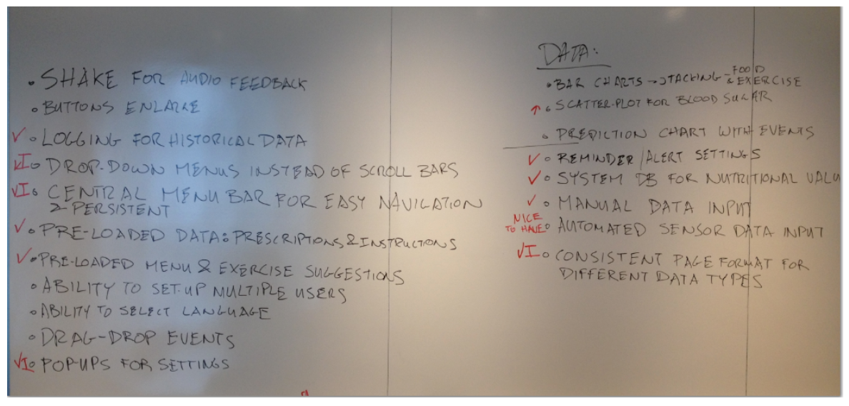.

# SYSTEM’S ADVANTAGE

Our final application is easy to understand and use even for seniors who are not used to technology and provide centralized access to the current and history of blood glucose levels. We expect our system is able to correctly predict variance in the blood glucose levels and use this information to provide goos advice and healthy choices. In order to provide this healthy options, our system will have a large database of healthy meals to use as meal suggestion.

Moreover, our application has a straightforward interface, facilitating the use for the senior who has difficulties with technology.

Lastly, our application has a good, well-organized and useful reminders section, which controls meal and exercise types and time, and the correct time to schedule insulin doses.

# Conclusion

In this project, we develop an interface to an application to help seniors to self-manage their diabetes. We started collecting information about diabetes and health self-management, and then created some research instruments to get direct information from seniors. After finding some volunteers and collecting information about their regular routine within the diabetes self-management, we developed a first design prototype and tested it in an evaluation session with other researchers also working with design and user interaction. We got feedback from the evaluation session and changed some functions and small issues on the design and got as result a good, simple and useful prototype to help seniors manage their diabetes.

# ACKNOWLEDGMENTS

We thank all the senior who volunteered to our research, providing information about their regular activities to manage their health issues. Also, we thank our instructor Velian Pandeliev and our Teacher Assistant Jessica, who wrote and provided helpful comments during the different stage of this project.

# REFERENCES

1. Breland, J. Y., Yeh, V. M., & Yu, J. (2013). Adherence to evidence-based guidelines among diabetes self-management apps. Translational behavioral medicine, 3(3), 277-286.
2. Chatterjee, S., & Price, A. (2009). Healthy living with persuasive technologies: framework, issues, and challenges. Journal of the American Medical Informatics Association, 16(2), 171-178.
3. Fogg, B. J. (2009, April). Creating persuasive technologies: an eight-step design process. In Persuasive (p. 44).
4. Hirsch, T., Forlizzi, J., Hyder, E., Goetz, J., Kurtz, C., & Stroback, J. (2000, November). The ELDer project: social, emotional, and environmental factors in the design of eldercare technologies. In Proceedings on the 2000 conference on Universal Usability (pp. 72-79). ACM.
5. Hunt, C. W., Sanderson, B. K., & Ellison, K. J. (2014). Support for Diabetes Using Technology: A Pilot Study to Improve Self-management. Medsurg Nursing, 23(4), 231-237.
6. King, D. K., Toobert, D. J., Portz, J. D., Strycker, L. A., Doty, A., Martin, C., ... & Glasgow, R. E. (2012). What patients want: relevant health information technology for diabetes self-management. Health and Technology, 2(3), 147-157.